**Extension:** Task 19

**Title:** Messaging Extended

**Author:** Sam Huffer, 101633177

# Goals / deliverables:

* Extend the previous spike to include one or more of the following:
  + Broadcast messages (specified by the sender)
  + Filtering of messages before delivery / pickup (by the blackboard / dispatch system, not the sender),
  + Scheduling of messages for the future
* You need to produce:
  + Updated design documents as applicable, clearly showing what you have had to add to support your additional features
  + Updated working code demonstration within Zorkish
* Notes:
  + You may like to include the ability for senders to cancel messages to support the above features.
  + Message filtering could be based on game entity values/types, or locations.
  + A message system is often a key part of any combat system. This might be a good target for you.

# Technologies, Tools, and Resources used:

* 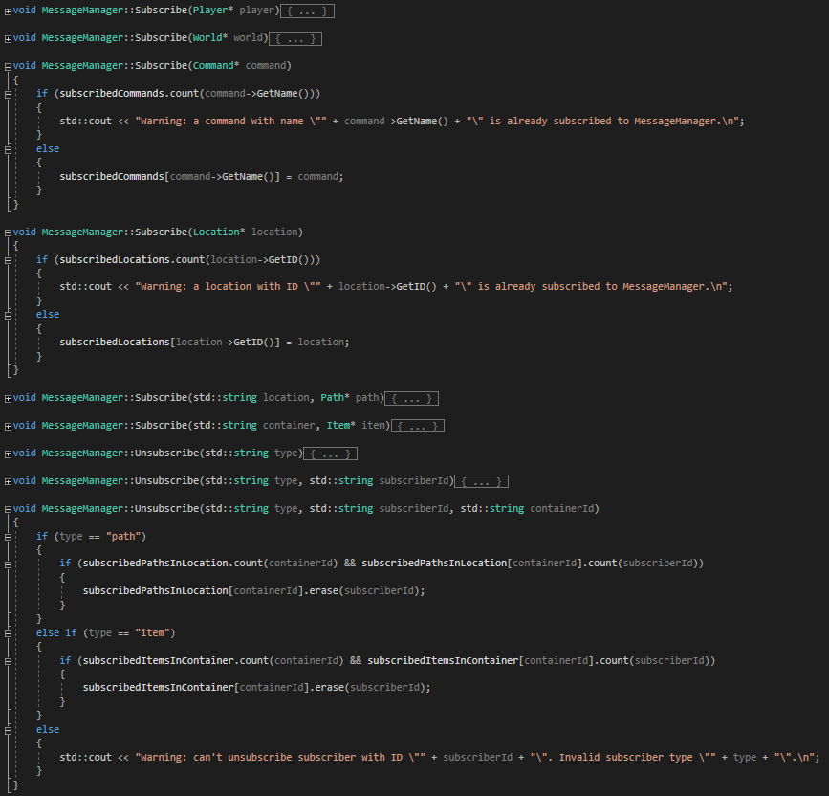Visual Studio 2019
* Microsoft Word
* Draw.io

# Tasks undertaken:

* I copied the “Zorkish Adventure” project and the task 18 spike report into the task folder, stripping out the spike report’s original content and replacing it with goals and resources pertaining to the task at hand.
* I had a look through the task instructions and considered what I could build to demonstrate the suggested features. I put together a UML class diagram for the required classes that would need to be added or changed, and planned what order I would tackle required changes in.
* I removed MessageManager’s existing one-size-fits-all Subscribe(), Unsubscribe() and subscribers members, and replaced them with members suited for storing and handling 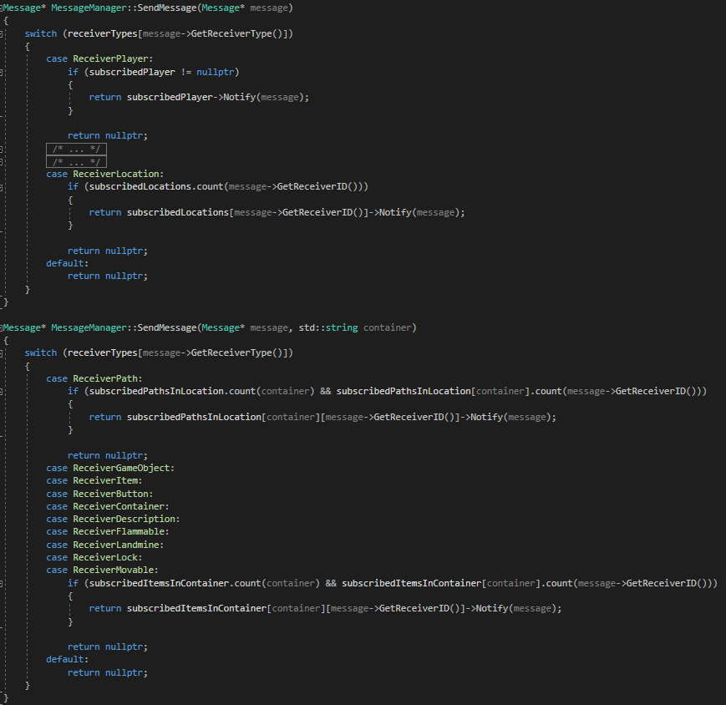Players, Worlds, Commands, Locations, Paths and Items separately (fig. 1). I then updated SendMessage() to distinguish between types of Message recipients through an enum-using switch statement, and pass the message to objects in the appropriate list (fig. 2).

Figure : MessageManager’s Subscribe() and Unsubscribe() methods, with some open to convey how those ones specifically work, and give a general sense of how different GameObject types are handled.

Figure : MessageManager.SendMessage()’s overloads and how they handle their respective GameObject types.

* 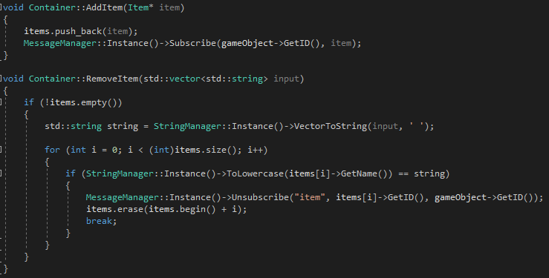I went through World.World() and found all now erroneous calls to MessageManager.Subscribe(), and updated them on a type-by-type basis to use the correct, overloaded Subscribe() method for that type. I removed the Subscribe() call for items, and added Subscribe() and Unsubscribe() calls to Container.AddItem() and RemoveItem() respectively to 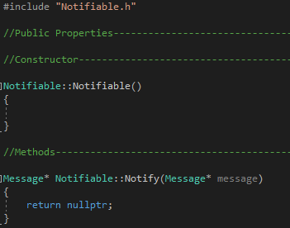ensure Items are subscribed under the correct container (fig. 3).

Figure : Container’s updated AddItem() and RemoveItem() methods.

* I went through each class that had a Notify() method and made it or its parent class inherit from Notifiable, with Notify() being a virtual method of Notifiable that just returns a nullptr unless overridden (fig. 4).
* I added to GameObject a field containerId to store the ID of the Container Item or Location holding a GameObject, and added to Container.AddItem(), Container.RemoveItem() and Location.AddPath() calls to public properties to set the GameObject’s containerId to be the GameObject.id of the containing GameObject. While doing so, I also updated Location.AddPath() to subscribe the added path to the MessageManager under the Location’s ID, and removed the call for that in World.World().

Figure : Notifiable.cpp. Notifiable only has its constructor and the virtual method Notify() as members.

* 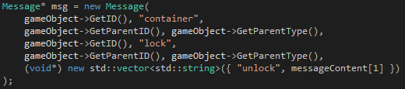I updated Message’s constructor to request the ID and type of the Message’s sender and recipient Notifiables, storing them in appropriate fields and accessible with appropriate public properties. Then, I updated all calls to Message’s constructor to fit the new parameters (fig. 5), before combining MessageManager’s overloaded SendMessage() methods, with the cases that would have used the passed string parameter now calling message->GetReceiverParentID() instead (fig. 6). Next, I updated all calls to SendMessage() to not pass any string parameters.

Figure : MessageManager.SendMessage()’s updated case ReceiverPath, using the Message.GetReceiverParentID() public property.

Figure : a new message in Container.cpp using the new parameter setup.

* TODO: assess CommandOpen to see if it can go hand in hand with filtering changes to remove needing fields of a particular object.
* TODO: add Button, Landmine and Flammable Component classes
  + Skeletons
  + Text file specification
  + World.World() handling
  + Internal behaviour

# What we found out:

* Filtering is good for restricting messages to being send-able only to game entities at a particular Location and/or of a particular type.
* Filtered broadcasting is good for triggering behaviours of all game entities of a particular type at a particular Location.

# Task 19 – Messaging Extended – Design Diagram